Heritage Statement

for

Proposed Adjustment of Staircase/Means of Escape
From Basement including a
New Staircase and Formation of New External Fire Exit Doorway

at

134 Sandgate Road,
Folkestone
Kent CT20 2BW

On behalf of

The Trustees of the Viscount Folkestone (1963) Settlement

Prepared By

S. I. Chartered Building Surveyors
8 Jointon Road
Folkestone
Kent CT20 2RG

Tel No. 01303-240088
Email: stuart@sicbs.co.uk

HERITAGE STATEMENT

The following details should be read in conjunction with submitted drawing no. 007/19/01. The property is known as 134 Sandgate Road, but is sometimes known as 134a or 132 Sandgate Road under the Listed status. The property is located on the corner of Sandgate Road and Manor Road. The ground and basement areas of this building are currently vacant following the recent closure in 2018 of the Royal Bank of Scotland. It was formerly the Williams & Glyns Bank, until it was absorbed into the Royal Bank of Scotland in 1985. The two upper floors to the building are occupied by a Solicitors firm.

The property was listed in 1975 under the Listing No. 1061179 and is Grade II Listed. The property is believed to have been constructed around 1890 in the style of the Grand and New Metropole Hotels. The bank itself is two storeys (including the basement) in red brick with buff tiled dressing, but the building four storeys overall, under a green slate roof. The front elevation has a corner octagonal turret. There is also a Venetian window to the first floor and cambered windows to the ground floor. The frontage facing Manor Road has three dormers, two further octagonal turrets which are decorated with wreaths.

To the rear/side of the property (north elevation) there is a timber framed garage and store which has a large basement that encroaches under the pavement to the rear access and adjoins the neighbouring property. The current means of escape from the basement area is through this building which is suffering from serious deterioration, despite it being a much later structure.

Development Proposals:

The proposal is to provide a secondary means of escape from the current basement due to the current fire exit being through the dilapidated garage/store building to the north of the site. This means of escape is unacceptable under current requirements and in particular Part B of the Building Regulations. The proposal is therefore to provide a staircase in the location of the current goods lift that is located between the ground and basement. This goods lift having been installed by the bank to provide access to the strong room that is still located within the basement.

The provision of an improved means of escape has now become an essential requirement for any potential future occupiers of the vacant banking hall and basement area.

Impact Assesment:

The property is Grade II Listed and is in the Folkestone Town Centre Conservation Area. The works proposed are mainly internal which has the minimal impact upon the grounds for the listing of the property. The interior is very much of modern finishes, having been used as a banking hall for many years. The proposed new staircase and means of escape has been carefully located in the location where the current goods lift is located, being a much later modern addition to the building. As this is now not required, it is the ideal location for the forming the new staircase well and insertion of the steelwork required for the supporting walls and staircase trimming.

The location of the new fire exit has also been carefully considered so that it is to the rear of the single storey structure, that is a separate later construction to the main building and does not affect the reasons for listing. The new fire exit doorway is also located to the rear of the property so it is not directly visible from any of the road frontages.

The need for the improved means of escape is required to update the building up to current standards, but has been carefully positioned to have the minimum impact upon the Grade II listing.

Conclusion:

The impact of the much needed new means of escape and fire exit from the basement to the building has been carefully considered to have the minimum impact on the Grade II Listed status. The current means of escape through the existing rear store is total unsatisfactory and the new provision will allow this vacant commercial property to be brought back into a use deserving of its status.

The proposal will therefore fully conform with Local and National Planning Policy and therefore should be supported by the District Council.

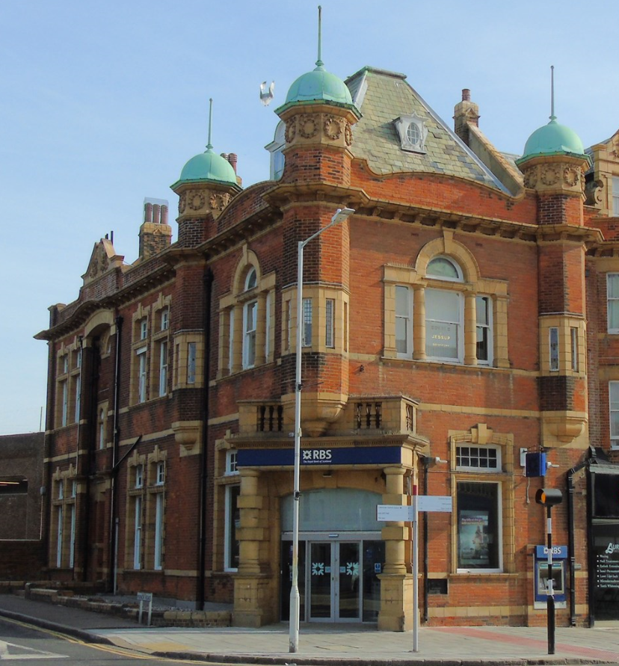

Front Elevation

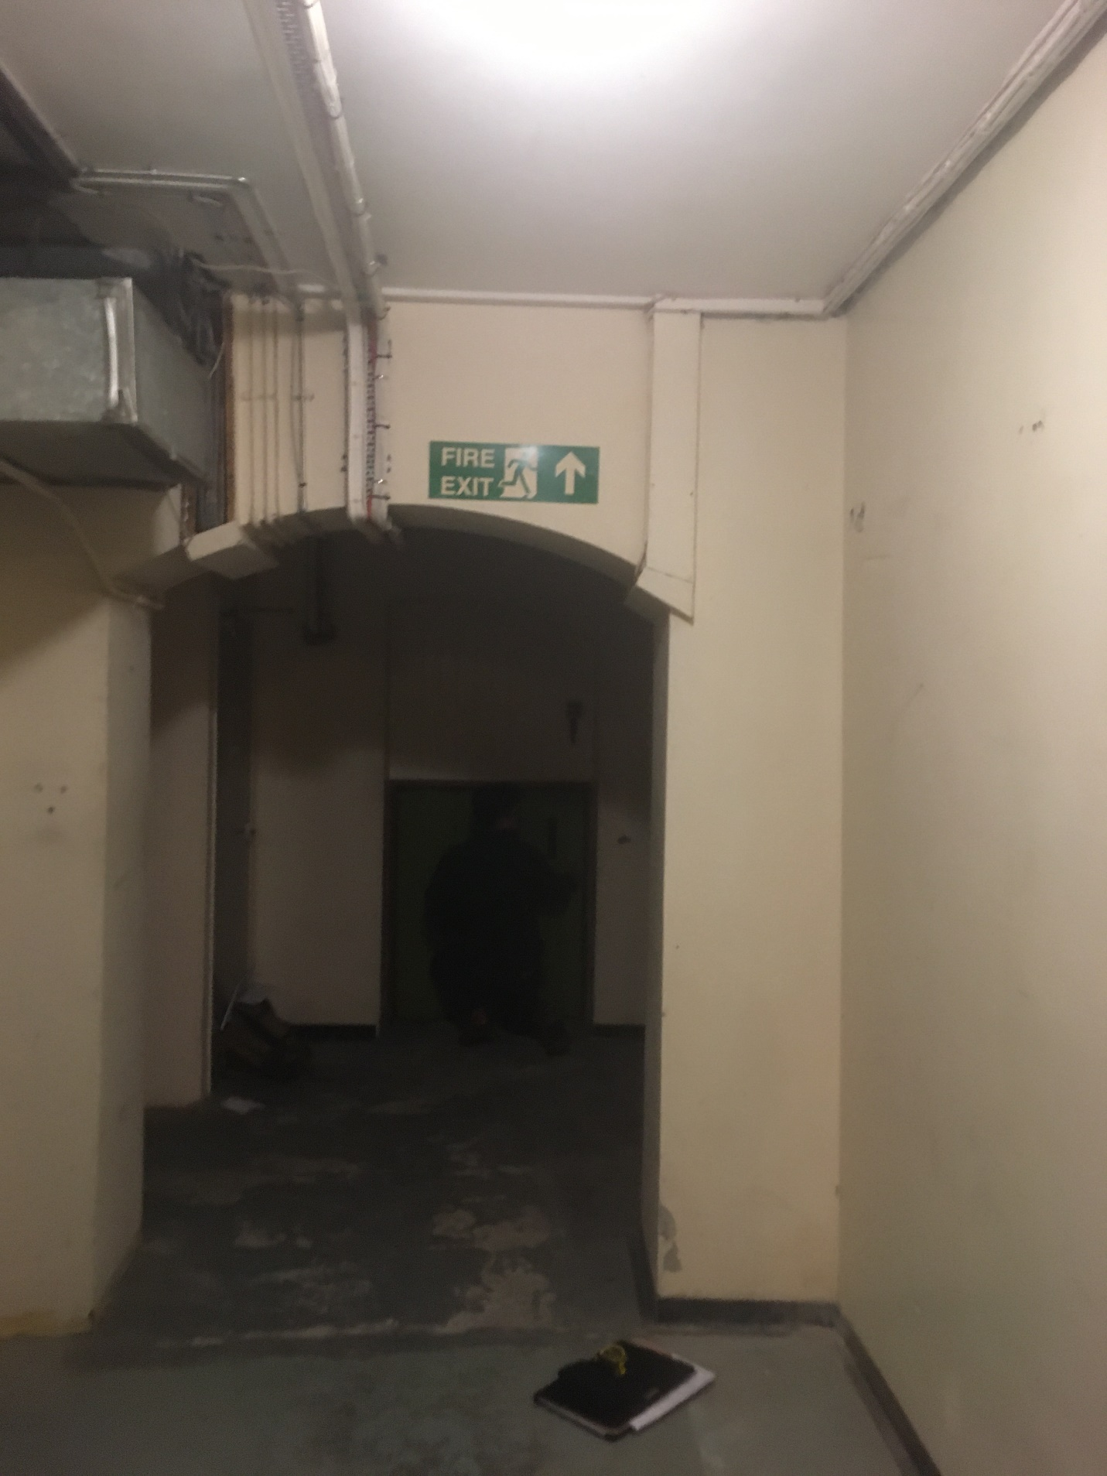

Proposed internal basement location of the staircase in the position of the current goods lift.

Location of the new external fire to rear garage/store.

