Design & Access Statement
(including the Conservation Area/Heritage Impact Statement)

for

Proposed self-containment of upper floor residential accommodation from the existing ground floor commercial area, including the provision of a
New shopfront, replacement windows and associated alterations

At

No. 12 Tontine Street
Folkestone
Kent
CT20 1JU

On behalf of
Godden Properties Limited

Prepared By
S. I. Chartered Building Surveyors
8 Jointon Road
Folkestone
Kent CT20 2RG

Tel No. 01303-240088
Email: - stuart@sicbs.co.uk

DESIGN & ACCESS STATEMENT

This statement must be read fully in conjunction with the application drawing no. 010/25/01.

1.0 Location: The property is located on the north side of Tontine Street close the intersection with the Old High Street as well as backing onto Harbour Way.

The ground floor is a former shop that was previously used for the sale of fishing tackle and associated goods, but has been empty since the purchase of the property by our Client’s in 2023. The ground floor commercial area is small and is not self-contained from the four storeys above which form part of the residential accommodation. Although this accommodation appears to have been vacant for a number of years. There is a combination of existing timber and UPVC windows to the property. The rear windows having been blocked up, which we would assume would have been for security purposes.

2.0 Planning
History: Following a review of the Local Authority Planning Website, there is no planning related history to the property.

3.0 Background: The ground floors of the property is a current commercial premises that includes an existing timber shopfront. It would appear that the building has been altered over a period of years with internal walls removed and similar alterations.

The upper floors are laid out for residential purposes and are set over four floors. Access to the upper floors is by an internal staircase which can only be afforded access via the current ground floor commercial premises.

The Applicants have recently purchased this vacant property and have been marketing it for potential tenants since January 2024. There has been no significant interest due to the limited size of the ground floor commercial area and the overall condition of the building.

The property is located within the commercial area of Tontine Street which is within the designated town centre Conservation Area. There has been significant redevelopment and improvement within the area and therefore the Applicants wish to upgrade the premises to a standard to match. As well as to attract potential lessees for both the commercial and residential areas to the building.

4.0 Amount: The current ground floor commercial area is 27m². The upper floor residential areas have a combined floor area of approximately 70.55m². Following the intended alterations, the ground floor commercial area will be 20.4m² and the residential floor area 77.55m². The overall site area for the property is approximately 0.003 hectares.

5.0 Proposal: The application seeks planning permission for the proposed self-containment of the upper floor residential accommodation from the ground floor commercial area, along with the provision of a new timber shopfront and associated alterations. These improvements are required to upgrade the residential accommodation to the upper floors and also to comply under Part B (fire) of the Building Regulations. In particular, the means of escape from the upper storeys. The refurbishment of the ground floor commercial area is required to attract potential tenants for to the commercial areas.

The upper floor maisonette does not currently have any bathroom facilities other than a w.c. The proposal is therefore to provide a full shower room and upgrade of the current w.c. The remaining living accommodation will also be improved including the provision of new replacement double glazed timber windows both to the front and to the rear, where the former window openings are to be reopened and similar timber windows are to be provided. These are to be sash style windows to be in-keeping with the Conservation Area. A general upgrade of the residential accommodation along with its self-containment will provide a significant improvement to the property and the living accommodation. Under the Core Strategy Review 2022, this improvement will accord with Policy HB1, HB3 and HB8. Within Policy HB3 this sets out the space standards for residential units. The current floor area would likely comply with the latest National Technical Housing Standards. The proposed conversion also will accord with the National Planning Policy Framework (NPPF) particularly under Paragraphs 195 – 208. The reuse of upper floor accommodation within in town centres is encouraged under current planning and government policy, in order to bring life and vitality into town centres. Particularly in the evenings.

The ground floor commercial area is to be retained, but the provision of a new timber shopfront, will be more in-keeping with a traditional design and allows for recessed door access both for the commercial area and a separate access for the upper floor residential accommodation. Although this will reduce the commercial area, it is hoped that with the upgrade of the facility that a commercial operator can be found for a small unit. The new shopfront is to incorporate a glazed sliding screen that could possibly allow for the serving of products and goods from the window directly onto the street, such as an ice cream vendor or similar. The need to provide options on this design is required to attract potential tenants for the property. As stated previously, the property has been marketed since 2024 with little or no interest.

The Local Planning Policy RL2 seeks to retain town centre uses at ground floor level. This has been fully complied with due to the refurbishment of the ground floor commercial unit along with the improvement of a new timber shopfront to replace the poor quality one that currently exists.

6.0 Appearance The full refurbishment of the property externally will significantly improve the visual appearance of the building. The replacement of poor-quality timber windows with new double glazed timber windows, along with a new timber shopfront will improve the living and thermal qualities to the building as well as the overall appearance. The use of timber within the Conservation Area will fully meet the requirements of Paragraph 205 of the NPPF and would benefit the visual aspect to this area of Tontine Street.

The property is showing significant signs of its age, and the refurbishment of the property will improve not only its visual appearance within the street scene but will be a significant benefit to the Conservation Area. The alterations will therefore be fully compliant with current Local Planning Policy and current consents issued within the Town Centre Conservation Area.

7.0 Parking
& Highways: The property is located in the town centre and is deemed a suitable location within an urban area. There are no external areas to the property and therefore there are no current parking provisions.

As there is no access to the rear of the property from the residential or commercial areas, there is therefore no agreeable location for a cycle store and the similar applies to both to bin storage and recycling.

8.0 Conclusion: The proposed refurbishment has been designed to have a positive impact on the host building and general surrounding environment. It is hoped that the commercial interest for the ground floor will significantly improve with the full building refurbishment. The upper floor residential accommodation will be brought back into an acceptable habitable condition. Providing a suitable property for sale or rent.

The proposed works will fully comply with Local and NPPF policies and general requirements. The proposal is therefore considered acceptable in terms of its impact on the amenities of the neighbouring occupants in adjacent properties, as well as retaining its commercial frontage. The outlook and windows will maintain required privacy and the main windows predominantly facing onto the adjoining street. The use of traditional and matching materials for the area, as well as being able to comply with current sustainable and thermal requirements for upgraded residential dwellings.

The development proposed is to be to a high-quality design and will not have a detrimental impact on the immediate properties or on the character and appearance of the Conservation Area. The standards of the new residential accommodation will be good, and the proposal will not have an adverse effect on the road network or local parking conditions.

For the above reasons, the proposal scheme is considered to be in accord with all the required Local and National Planning Policies.

CONSERVATION/HERITAGE IMPACT

The key consideration relating to the impact on the Conservation Area are set out within the accompanying Design & Access Statement and also have been considered on the application drawing no. 010/25/01.

The overall design provides a sustainable development and contributes to its location within the Tontine Street Conservation Area. This therefore will fully comply with Paragraphs 124 &127 of the NPPF. The alterations will function well and add to the overall quality of the area, not just for the short term, but over the lifetime of the property. The current property being of a poor standard of repair and requiring significant investment and upgrading. The new shopfront and external alterations will be visually attractive as a result of good architectural layout and design, as well as being sympathetic to the local character and history of the area.

Under the NPPF, the impact of the development has several key tests on proposals relating to designated and non-designated heritage assets. As the property is non-listed and is of limited design merit, the proposal will therefore have no impact on the Conservation Area but would provide an improved traditional design and upgrade to the building. As well as bringing back into use much needed residential accommodation to the upper floors and provide a better chance of leasing the small commercial unit to the ground floor.

The proposed designs with therefore fully comply with the Conservation Area Section 72 of the Planning (Listed Building & Conservation Areas) Act 1990 in respect to the preserving and enhancing the character and appearance of the area. This is accomplished through a positive contribution and leaves the character and appearance of the area unharmed. This reinforces the principles of the NPPF.

The proposed alterations will therefore have a positive impact on the host building and general surroundings of the Conservation Area. It will therefore fully comply with all Local Planning Policies relating to the location and neighbouring designated heritage assets.

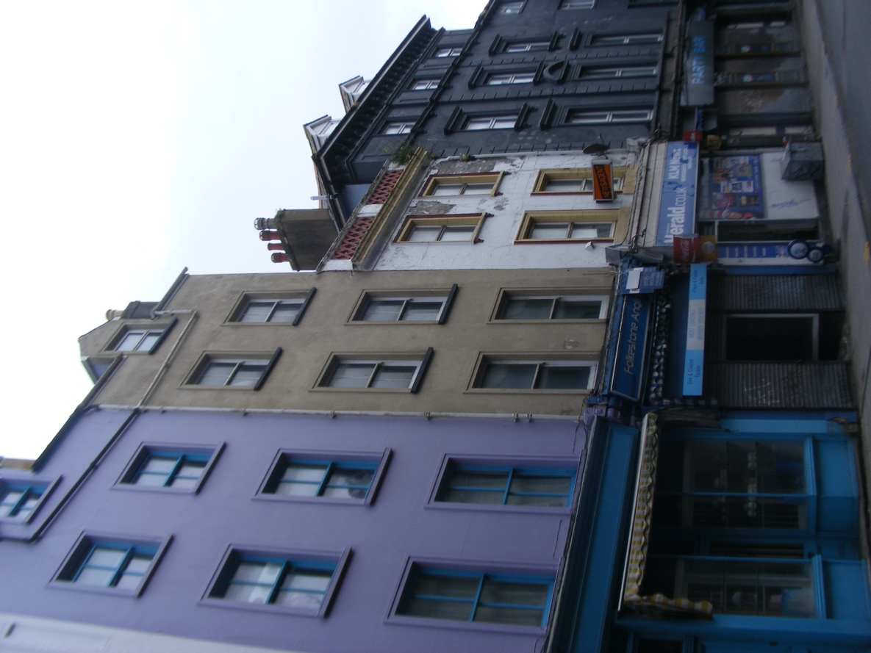

Existing front elevation onto Tontine Street

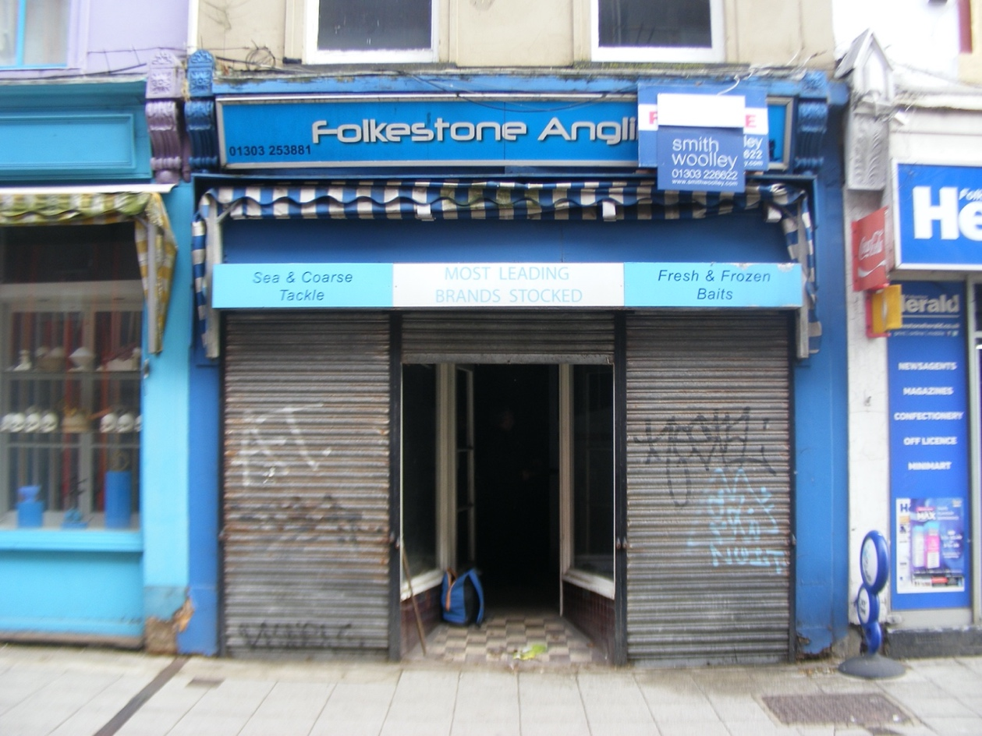

Existing shopfront

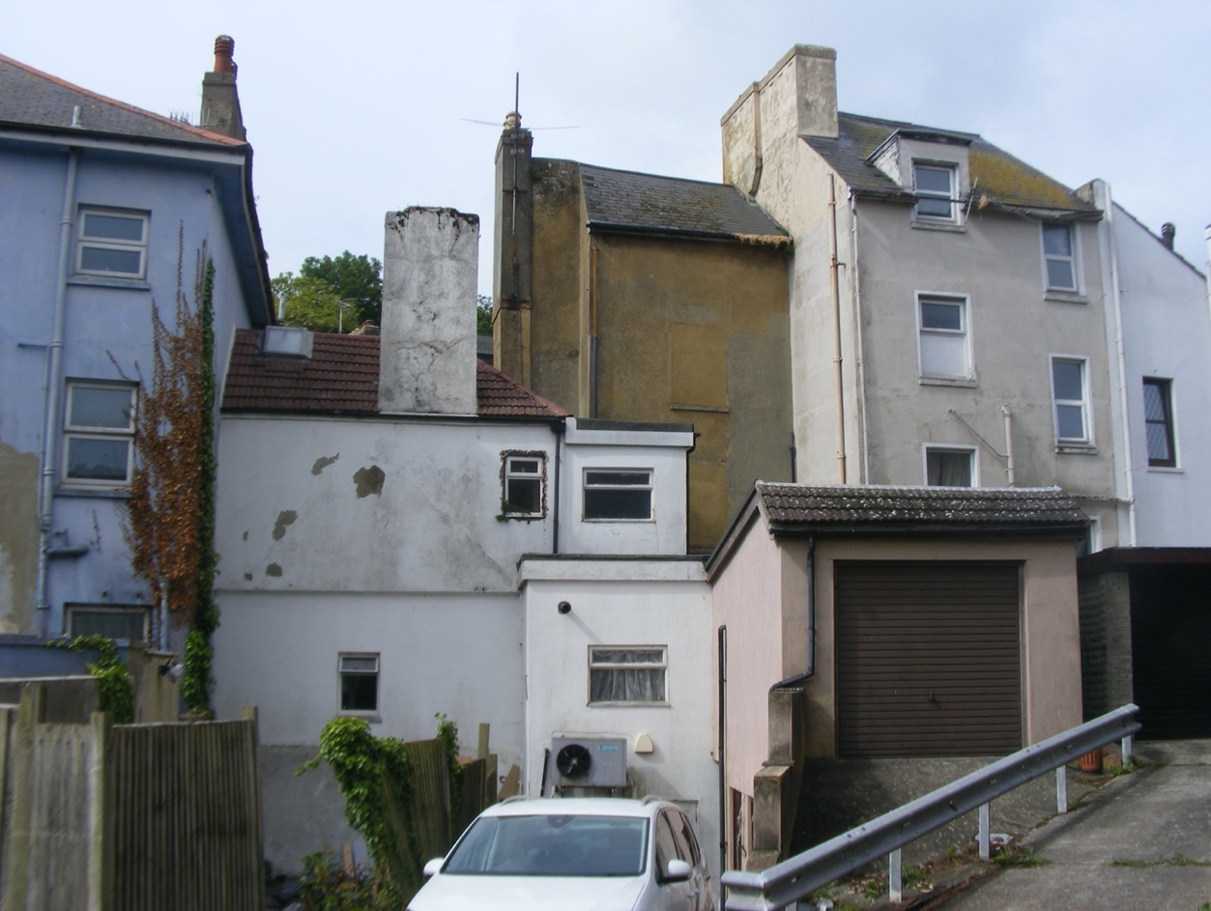

Rear elevation of property and adjoining properties

